-->Check the table below (you need to be a sys admin on SQL for it)

select * from sys.symmetric_keys

select * from sys.asymmetric_keys

-->The **Orch keys were not available**. In a working scenario the output of this table would look like below

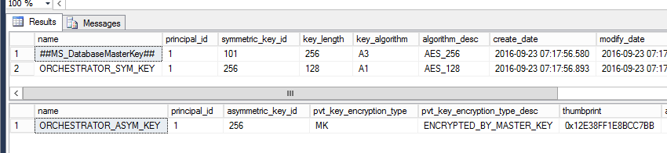

-->We created the key using the SP on Orchestrator DB

[Microsoft.SystemCenter.Orchestrator.Cryptography].[CreateOrchestratorKeys]

-->Since it was still not working, permissions to the symmetric and asymmetric Orchestrator encryption keys were explicitly granted to the

[Microsoft.SystemCenter.Orchestrator].Admins,

[Microsoft.SystemCenter.Orchestrator].Operators and

[Microsoft.SystemCenter.Orchestrator].Runtime database roles.

*To do this, please follow the steps below:*

1. Connect to Orchestrator DB and expand security à Roles à Database Roles.
2. Right click on “[Microsoft.SystemCenter.Orchestrator].Admins” à properties à Securables
3. Click on Search and select “Specific Objects..” à Ok
4. For Object Type, select “Asymmetric Keys“

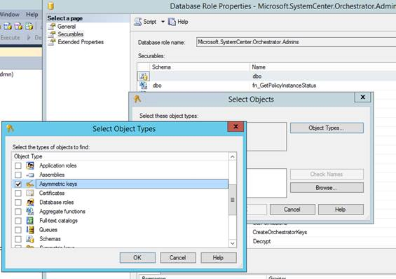

1. For the next box, click browse and select the Asymmetric keys created for Orch DB. (please refer to screenshot above)
2. Under permission, please provide “controlàgrant” permission

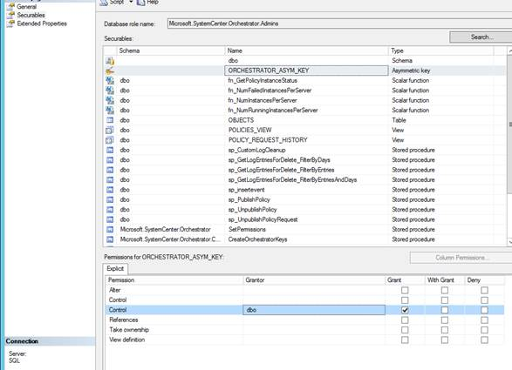

1. Follow the steps b. – e. for Symmetric keys as well.

Similarly add the permissions for User roles below

[Microsoft.SystemCenter.Orchestrator].Operators and

[Microsoft.SystemCenter.Orchestrator].Runtime